REPUBLIC OF THE PHILIPPINES

BICOL UNIVERSITY

BICOL UNIVERSITY POLANGUI

## **WELCOME TO THE SHOPPING CART SYSTEM CODE:**

**#include <iostream>**

**#include <iomanip>**

**#include <string>**

**Using namespace std;**

**// Node structure for the Binary Search Tree**

**Struct Node {**

**Int orderId;**

**String itemName;**

**Double price;**

**Node* left;**

**Node* right;**

**Node(int id, string name, double price) : orderId(id), itemName(name), price(price), left(nullptr), right(nullptr) {}**

**};**

**// Binary Search Tree class**

**Class ShoppingCart {**

**Private:**

**Node* root;**

**Int itemCount; // Track the number of items in the cart**

**Const int MAX_ITEMS = 5; // Maximum allowed items**

**// Helper function to insert an item**

**Node* insert(Node* node, int orderId, string itemName, double price) {**

**If (node == nullptr) {**

**Return new Node(orderId, itemName, price);**

**}**

**If (price < node->price) {**

**Node->left = insert(node->left, orderId, itemName, price);**

**} else {**

**Node->right = insert(node->right, orderId, itemName, price);**

**}**

**Return node;**

**}**

**// Helper function for pre-order traversal**

**Void preOrderTraversal(Node* node, string& result) {**

**If (node == nullptr) return;**

**Result +=”Php “ + to_string(node->price) + “, “;**

**preOrderTraversal(node->left, result);**

**preOrderTraversal(node->right, result);**

**}**

**// Helper function for in-order traversal**

**Void inOrderTraversal(Node* node, string& result) {**

**If (node == nullptr) return;**

**inOrderTraversal(node->left, result);**

**result +=”Php “ + to_string(node->price) + “, “;**

**inOrderTraversal(node->right, result);**

**}**

**// Helper function for post-order traversal**

**Void postOrderTraversal(Node* node, string& result) {**

**If (node == nullptr) return;**

**postOrderTraversal(node->left, result);**

**postOrderTraversal(node->right, result);**

**result +=”Php “ + to_string(node->price) + “, “;**

**}**

**Public:**

**ShoppingCart() : root(nullptr), itemCount(0) {}**

**// Public method to add an item to the cart**

**Void addItem(int orderId, string itemName, double price) {**

**If (itemCount >= MAX_ITEMS) {**

**Cout << “The cart is full! You can only have up to “ << MAX_ITEMS << “ items.” << endl;**

**Return;**

**}**

**Root = insert(root, orderId, itemName, price);**

**itemCount++;**

**cout << “Item ‘” << itemName << “’ added to cart for Php “ << fixed << setprecision(2) << price << endl;**

**}**

**// Public method to display items in a specified traversal order**

**Void displayItems(string traversalType) {**

**If (root == nullptr) {**

**Cout << “The cart is empty!” << endl;**

**Return;**

**}**

**String result;**

**If (traversalType == “Pre-order”) {**

**preOrderTraversal(root, result);**

**} else if (traversalType == “In-order”) {**

**inOrderTraversal(root, result);**

**} else if (traversalType == “Post-order”) {**

**postOrderTraversal(root, result);**

**} else {**

**Cout << “Invalid traversal type!” << endl;**

**Return;**

**}**

**// Remove the trailing “, “ and display the result**

**If (!result.empty()) result.pop_back(), result.pop_back();**

**Cout << traversalType << “: “ << result << endl;**

**}**

**};**

**Int main() {**

**ShoppingCart cart;**

**Int choice, orderId;**

**String itemName, traversalType;**

**Double price;**

**Cout << “Welcome to the Shopping Cart System!” << endl;**

**While (true) {**

**Cout << “\nMenu:” << endl;**

**Cout << “1. Add an item to the cart” << endl;**

**Cout << “2. Display cart items (Pre-order,In-order,Post-order)” <<endl;**

**Cout << “3. Exit” << endl;**

**Cout << “\n”<<”Enter your choice: “;**

**Cin >> choice;**

**Switch (choice) {**

**Case 1:**

**Cout << “Enter order ID: “;**

**Cin >> orderId;**

**Cout << “Enter item name: “;**

**Cin.ignore();**

**Getline(cin, itemName);**

**Cout << “Enter item price: “;**

**Cin >> price;**

**Cart.addItem(orderId, itemName, price);**

**Break;**

**Case 2:**

**Cout << “Enter traversal type (Pre-order,In-order,Post-order): “<<”\n”;**

**Cin.ignore();**

**Getline(cin, traversalType);**

**Cart.displayItems(traversalType);**

**Break;**

**Case 3:**

**Cout << “Exiting the system. Goodbye!” << endl;**

**Return 0;**

**Default:**

**Cout << “Invalid choice. Please try again.” << endl;**

**}**

**}**

**Return 0;**

**}**

## **EXAMPLE OUTPUT:**

**PROCESS:**

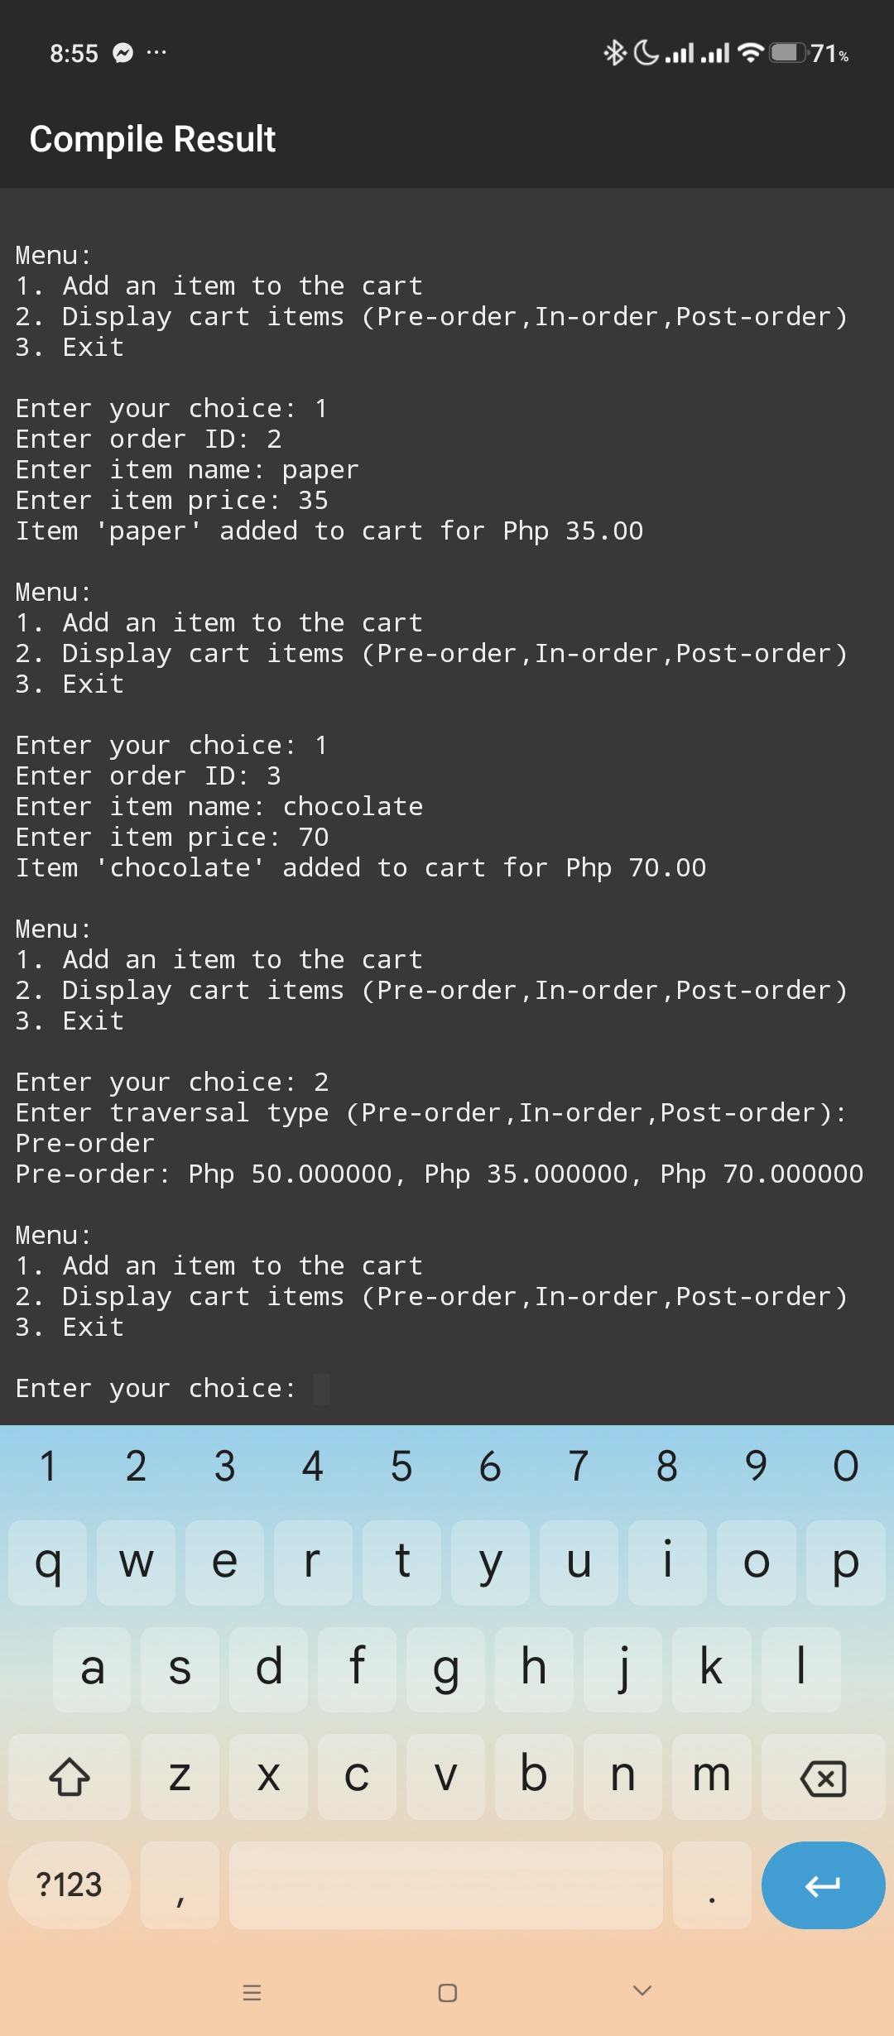

**DISPLAYING TRAVERSALS:**

